Sub Code : 18CSC302J

CSE F1

Computers Network

REG No. 1811003010344

Name : Vikash Mishra

**EXPERIMENT-10**

**IMPLEMENTATION OF FILE TRANSFER PROTOCOL**

**AIM:** To implement File Transfer Protocol using Socket Programming.

**CODING:**

**SERVER:**

#server

import socket # Import socket module

port = 60000 # Reserve a port for your service.

s = socket.socket() # Create a socket object

host = socket.gethostname() # Get local machine name

s.bind((host, port)) # Bind to the port

s.listen(5) # Now wait for client connection.

print('Server listening....')

while True:

conn, addr = s.accept() # Establish connection with client.

print('Got connection from', addr)

data = conn.recv(1024)

print('Server received', repr(data))

filename='mytext.txt'

f = open(filename,'rb')

l = f.read(1024)

while (l):

conn.send(l)

print('Sent ',repr(l))

l = f.read(1024)

f.close()

print('Done sending')

conn.send('Thank you for connecting'.encode())

conn.close()

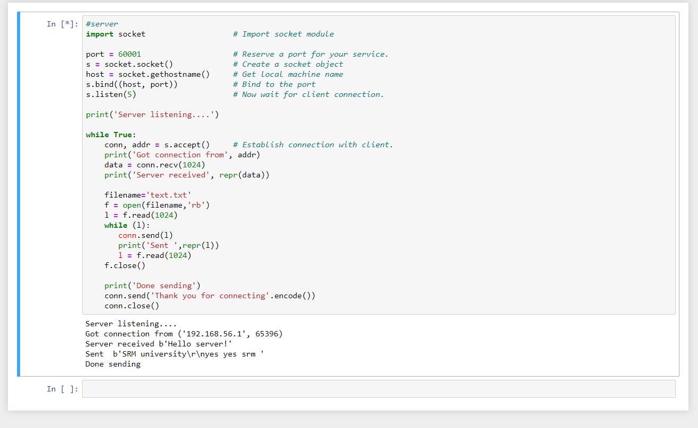

**CODING:**

**CLIENT:**

#client

import socket # Import socket module

s = socket.socket() # Create a socket object

host = socket.gethostname() # Get local machine name

port = 60000 # Reserve a port for your service.

s.connect((host, port))

s.send("Hello server!".encode())

with open('received_file', 'wb') as f:

print('file opened')

while True:

print('receiving data...')

data = s.recv(1024)

print('data=%s', (data))

if not data:

break

# write data to a file

f.write(data)

f.close()

print('Successfully get the file')

s.close()

print('connection closed')

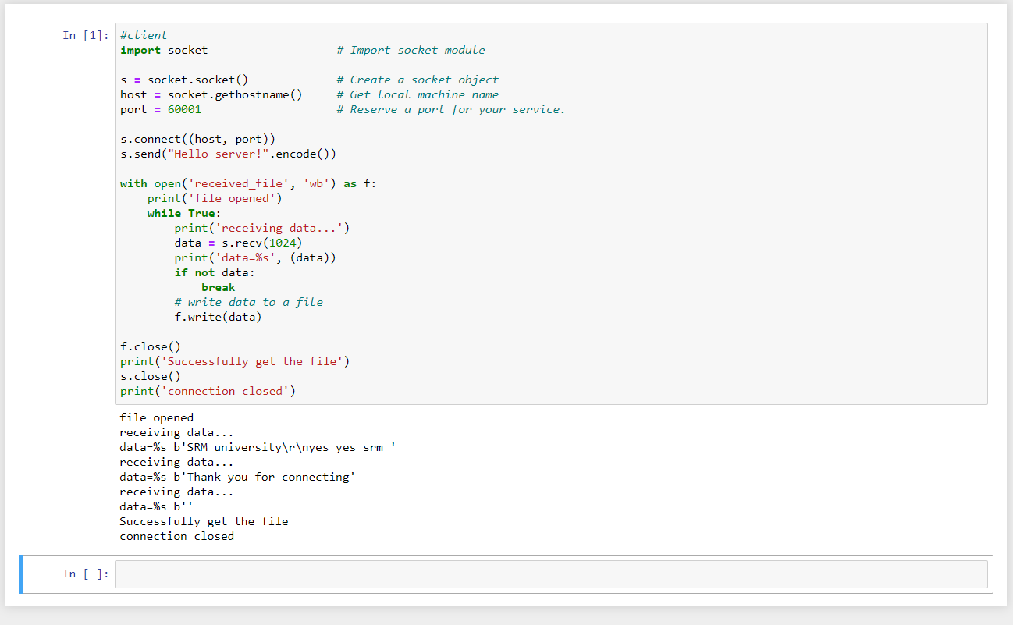

Sub Code : 18CSC302J

CSE F1

Computers Network

REG No. 1811003010344

Name : Vikash Mishra